"27 GAMES FOR NINTENDO SWITCH FOR £0.89”
That’s less than 4p a game!
Update: FUZE player FOR Nintendo Switch™
December 2020
Following their recent announcement: “the FUZE Player for Nintendo Switch is set for a 28th of December release”, FUZE are extremely happy to say that another five games have been added to the FUZE Showcase Gallery, bringing the total to 27 games available on release day.
The full games list is now as follows:
● Super Mega Arena Blaster ● Fast Food Dizzy for FUZE ● Crazy 3D Shooter ● Vecroids
● Ninja Scroll ● Know Your Plaice! ● FUZE Bounce ● Asteroid Navigator ● Genial Chess
● Patience Solitaire ● Super Laser Blast ● Motorway Memory ● Missiles
● No Escape from Red Hell ● Vi-Race ● AnimeUltraHyperJump ● Da Bean
● Shapes Mini Game ● Cube Puzzle Toy ● Skatey Cat ● Parasail Pat ● FUZE Fit Adventure 2
New games
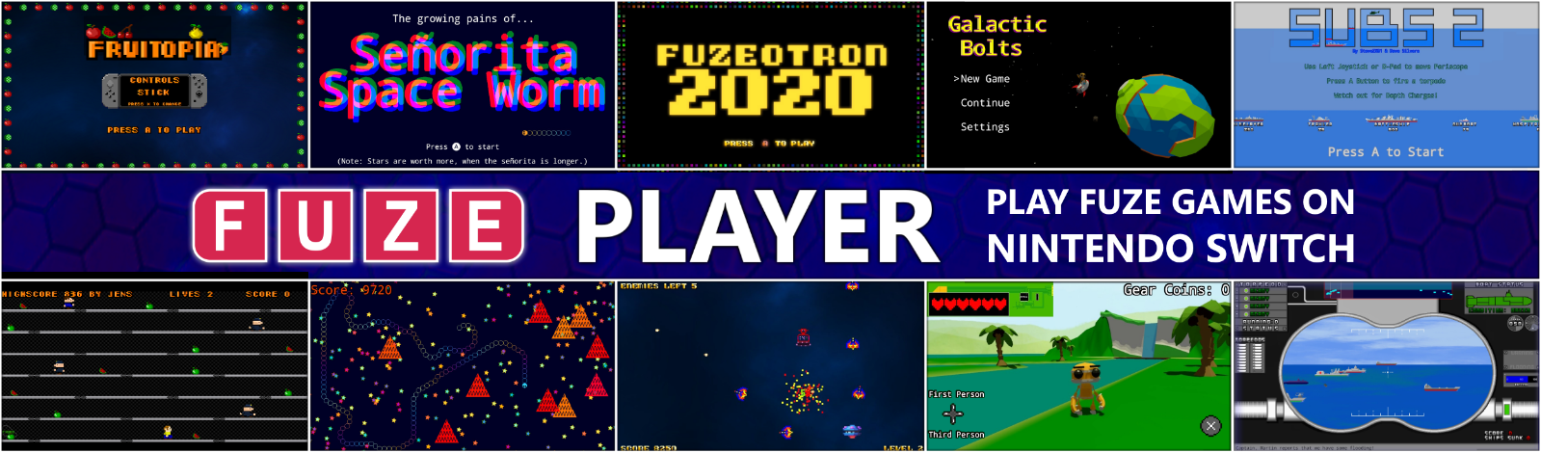
● FUZEOTRON ● Fruitopia ● Subs ● Galactic Bolts ● Senorita Space Worm
Even more 'Free to Download' titles are being added to the FUZE Showcase Gallery as they become available.
The FUZE Player for Nintendo Switch™ will be available on the Nintendo eShop from the 28th of December, worldwide, for the insanely low price of £0.89 / $0.99 / €0.99.
With FUZE Player for Nintendo Switch you can, play the built-in games, download lots more for free, view the code to see how they were made, and join the FUZE Arena Community where you can, if you have FUZE⁴ Nintendo Switch, submit your own games and apps.
And don't be put off by the low price as many of these games are worth far more than the selling price alone!

Check out the FUZE Player trailer here

For an overview of FUZE⁴ Nintendo Switch: https://www.fuze.co.uk/nintendo-switch
Visit FUZE Arena and join in with a community of enthusiastic coders eager to learn, collaborate, share tips and offer friendly advice. FUZE Arena runs regular Game Jams and competitions. Create a masterpiece, submit it to the Showcase Gallery for others to play all over the world.
Additional artwork is available here www.fuze.co.uk/press
For more information on FUZE please email contact@fuze.co.uk

