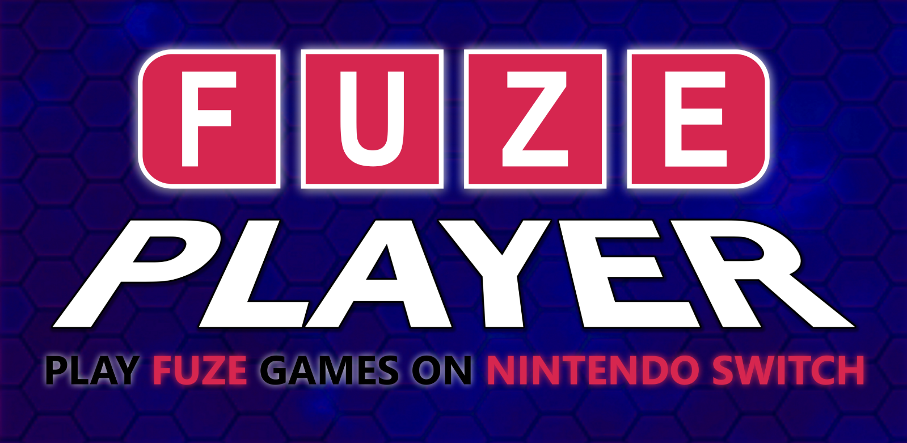

FUZE Technologies is very happy to announce
the FUZE player FOR Nintendo Switch
More than 20 Games for nintendo switch
for the ludicrousLY LOW price of $0.99
December 2020
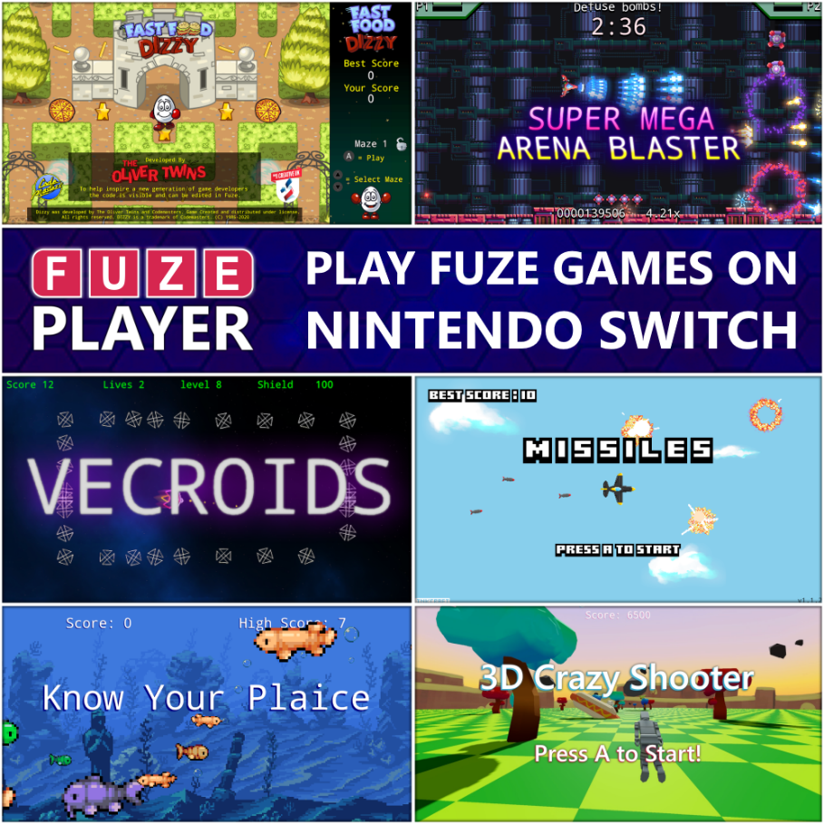
Just over a year since the launch of the award winning FUZE4 Nintendo Switch, the long awaited FUZE Player is set to launch in the Nintendo eShop on Monday the 28th of December 2020.
Over the last year, hundreds of games have been written using FUZE4 Nintendo Switch. The FUZE Showcase Gallery was created to highlight the best submissions. However as many of these are so good, FUZE decided it was best to make them available beyond the FUZE community, and so the FUZE Player will be available for an insanely low price of £0.89 / $0.99 / €0.99.
The initial release includes more than 20 games developed by FUZE and the FUZE Arena Community using the coding app FUZE4 Nintendo Switch.

Included Games:
● Super Mega Arena Blaster ● Fast Food Dizzy for FUZE
● Crazy 3D Shooter ● Vecroids ● Ninja Scroll ● Know Your Plaice!
● FUZE Bounce ● Asteroid Navigator ● Genial Chess ● Patience Solitaire
● Super Laser Blast ● Motorway Memory ● Missiles ● No Escape from Red Hell
● Vi-Race ● AnimeUltraHyperJump ● Da Bean ● Shapes Mini Game
● Cube Puzzle Toy ● Skatey Cat ● Parasail Pat ● FUZE Fit Adventure 2
… and even more 'Free to Download' titles are being added to the FUZE Showcase Gallery as they become available.
With FUZE Player for Nintendo Switch you can, play the built-in games, download lots more for free, view the code to see how they were made and join the FUZE Arena Community where you can, if you have FUZE4 Nintendo Switch, submit your own games and apps.
See what’s possible with the FUZE Player and if you think you've got what it takes to make the grade, then we'll be seeing you in the FUZE Arena where the FUZE community is constantly creating, learning, sharing and helping others to hone their coding skillz!
With more than 20 games included and many more to download for free, it's a no brainer, what are you waiting for - It's time to play!
Oh, and don't be put off by the low price, as many of these games are worth far more than the selling price alone!

Check out the FUZE Player trailer here

For an overview of FUZE⁴ Nintendo Switch: https://www.fuze.co.uk/nintendo-switch
Visit FUZE Arena and join in with a community of enthusiastic coders eager to learn, collaborate, share tips and offer friendly advice. FUZE Arena runs regular Game Jams and competitions. Create a masterpiece, submit it to the Showcase Gallery for others to play all over the world.
Additional artwork is available here www.fuze.co.uk/press
For more information on FUZE please email contact@fuze.co.uk

