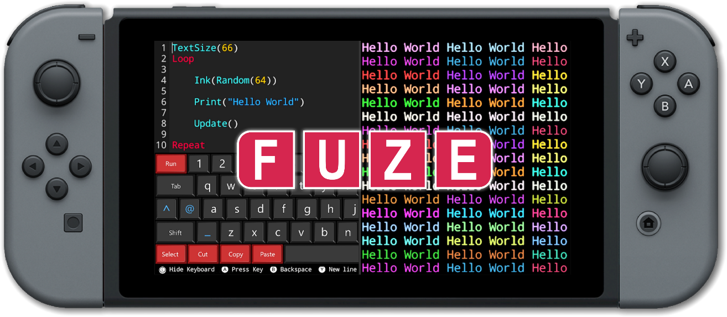

FUZE Technologies LAUNCHES RETRO coding competition with over £3,800 worth of prizes AND GIVEAWAYS!
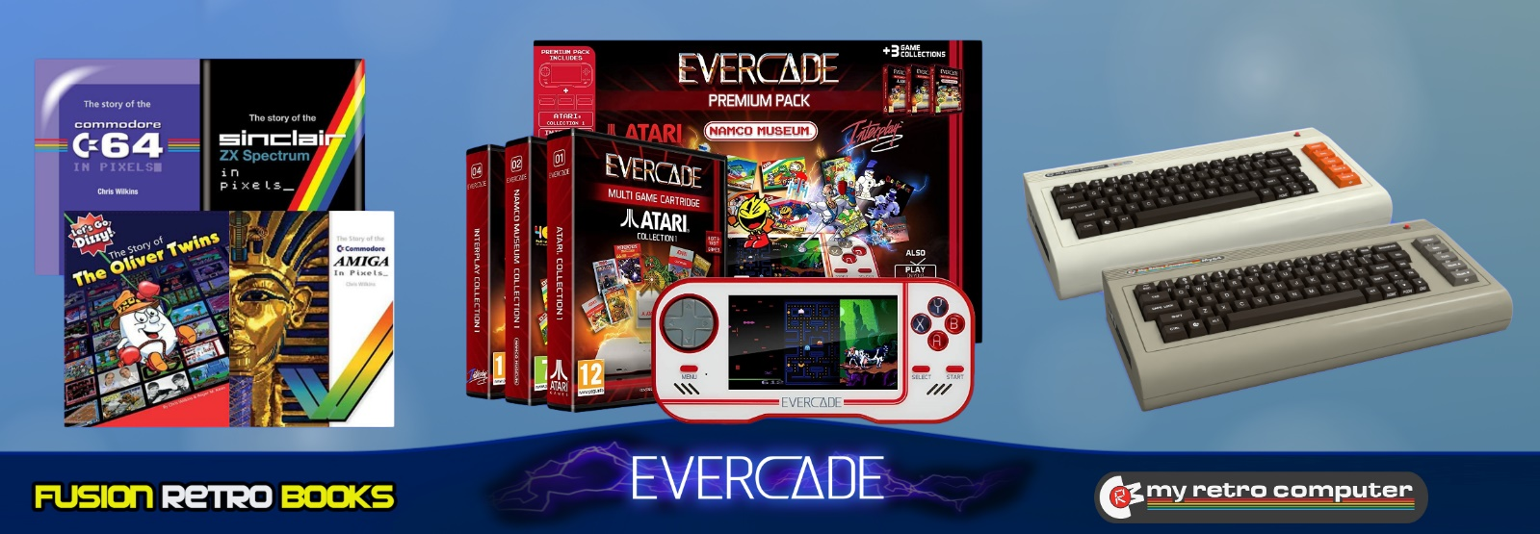
March 4th 2021
FUZE Technologies, creator of the popular FUZE⁴ Nintendo Switch coding platform is so excited to announce their coding competition in association Wireframe Magazine.
Have you always wanted to become a game developer or perhaps you have a ready-made game concept that’s just waiting to be put in to action? Code your game using FUZE⁴ Nintendo Switch. It can be any genre or style you like, as long as it’s retro-themed, coded using FUZE, and submitted via the platform by the closing date: Monday 19 April 2021.
What’s that, you don’t own FUZE⁴ Nintendo Switch? No problem! To support the competition FUZE is giving away up to 200 copies of its award-winning coding application worth £12.99 each, that’s over £2,500 worth of Nintendo Switch software for free!
Using FUZE⁴ Nintendo Switch entrants can create their game(s) and submit it to the judging panel for the chance to have their work appear on Nintendo Switch via the FUZE platform. Perfect for beginners and more experienced coders alike, FUZE⁴ Nintendo Switch is easy to use with step-by-step tutorials to get you started, even if you have no prior coding knowledge. There are no limits to the kind of games you can create – the only thing that can hold you back is your own imagination.
The competition will be announced in issue 48 of Wireframe Magazine which is available to buy from various newsagents and online, or can download for free from https://wireframe.raspberrypi.org/ from the 4th of March.
Full competition details along with instructions to claim your free download code are available at www.fuze.co.uk/wireframe.
You can enter multiple times and even win multiple prizes. Entrants can be any age but those twelve years or under must communicate via a parent or guardian. The competition closes on the 19th April 2021, so there’s plenty of time to get your entries in. The full list of prizes include:
5 Evercade handheld consoles and game packs worth over £530
16 Retro Fusion books worth over £300
2 My Retro Computer cases worth £378
A whole lot of Kudos and the chance to see your game published and available on Nintendo Switch via the FUZE platform!
For an overview of FUZE⁴ Nintendo Switch: https://www.fuze.co.uk/nintendo-switch
Visit FUZE Arena and join in with a community of enthusiastic coders eager to learn, collaborate, share tips and offer friendly advice. FUZE Arena runs regular Game Jams and competitions. Create a masterpiece, submit it to the Showcase Gallery for others to play all over the world.
Additional artwork is available here www.fuze.co.uk/press
For more information on FUZE please email jessica@bleatpr.com

