FUZE RETRO CODING COMPETITION
in association with

Magazine
Video game pioneers, eugene jarvis, jeff Minter and the oliver twins, join the panel of JUDGES FOR FUZE’s RETRO coding competition
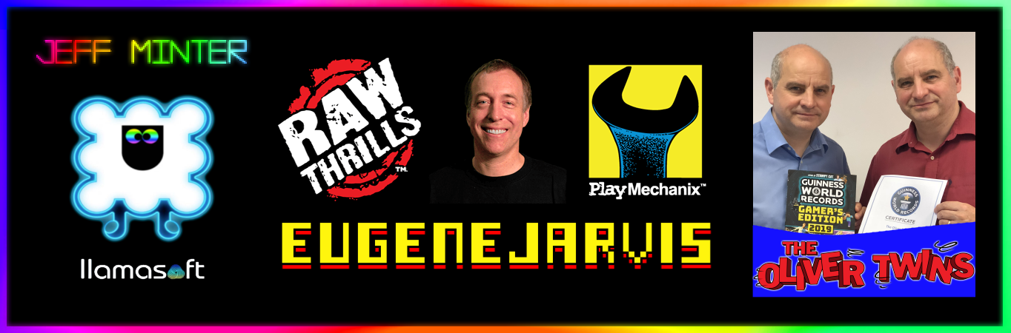

March 21st 2021
FUZE is honoured to announce the final panel of judges for its recently announced Retro Coding Competition.
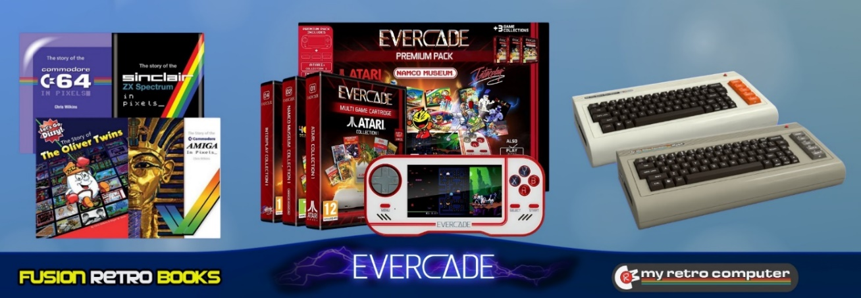
Jon Silvera, founder of FUZE Technologies Ltd comments, “We’re so excited to have Eugene Jarvis, Jeff Minter and The Oliver Twins join us in helping to choose the competition winners. Alongside the authoritative game-dev publication, Wireframe Magazine, we now have three industry icons who are perfect for the task. Who better than one of, if not the most highly regarded arcade game designers of all time, Eugene Jarvis, one of the longest standing, most innovative and psychedelically creative independent developers of all time, Jeff Minter, and the Guinness World Record holders for being the most prolific 8 Bit developers, the Oliver Twins! It just doesn’t get more ‘retrotastic’ that this folks!”
over £5,500 worth of prizes & GIVEAWAYS!

To support the competition FUZE has already given away more than £4,500 worth of FUZE⁴ Nintendo Switch for free, and there’s over £1,000 in prizes for the winning entries.
Using FUZE⁴ Nintendo Switch entrants can create their game(s) and submit it to the judging panel for the chance to have their work appear on Nintendo Switch via the FUZE platform. Perfect for beginners and more experienced coders alike, FUZE⁴ Nintendo Switch is easy to use with step-by-step tutorials to get you started, even if you have no prior coding knowledge. There are no limits to the kind of games you can create.
Also, due the growing number of giveaways and the incredible line-up of judges, the competition final submission date has been extended to the 30th of April so there’s plenty of time to create and submit your masterpiece. Full competition details are available at fuze.co.uk
Successful entries will be presented to the judging panel during the first half of May and the winners will be announced in Wireframe Magazine soon after. We will also be playing, and reviewing, the winners via a live streaming session, the date of which is to be confirmed.
FUZE has launched a Just Giving campaign where you can show your support and help us to giveaway more copies of FUZE⁴ Nintendo Switch and add more competition prizes.

Find out more about Eugene Jarvis at Raw Thrills
Find out more about Jeff Minter at Llamasoft
Find out more about The Oliver Twins at olivertwins.com
Find out more about Wireframe Magazine at Wireframe

Visit FUZE Arena and join in with a community of enthusiastic coders eager to learn, collaborate, share tips and offer friendly advice. FUZE Arena runs regular Game Jams and competitions. Create a masterpiece, submit it to the Showcase Gallery for others to play all over the world.
Additional artwork is available here www.fuze.co.uk/press
For more information on FUZE please email jon.silvera@fuze.co.uk

