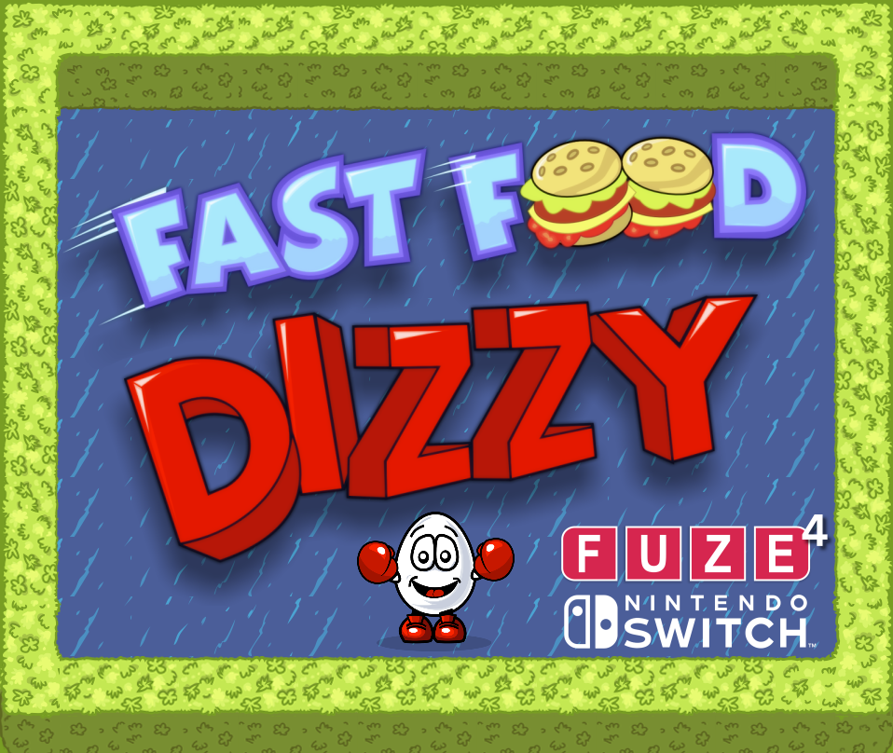

THE OLIVER TWINS & FUZE Technologies
ARE SO VERY ‘EGGCITED’ to announce
FAST FOOD DIZZY
‘EGGCLUSIVELY’ for FUZE⁴ Nintendo Switch
Available now with FUZE⁴ Nintendo Switch for the ‘eggstremely’ low price of ‘FREE’ – no yolk!
“We really enjoyed re-imagining one of our classic original Dizzy games, so much so, that we just kept adding features. It was easy to learn, extremely intuitive and very powerful. We hope people enjoy the game, and find it challenging and inspiring.“ - Philip Oliver
Date: November 4th 2020
Fast Food Dizzy for FUZE
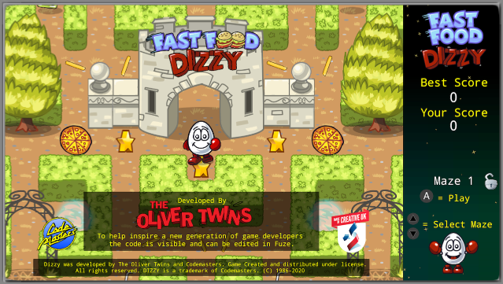
- Dizzy is back and he’s hungry, but the food doesn’t want to be eaten!
- Help Dizzy navigate 10 progressively complex mazes eating all the food, whilst avoiding the guards and using power-ups along the way
- Unlock 10 editable mazes to create your own fiendishly difficult challenges to share with friends and online
- ALL the code can be edited in FUZE to help you learn to program, make changes and even make your own games
- Action packed nutritious fun!
Features:
- 10 unique levels
- Power-ups
- Brand new original artwork by Jonathan Temples
- New and original soundtracks
- A level editor to create your own mazes
- Includes the full game source code for you to learn and modify in FUZE
“It's been fantastic working with the team at FUZE who so passionately believe, as do we, that the best way to encourage students to learn to code, is to give them the tools to help them make games. FUZE is the perfect solution as a stepping stone between Scratch and industry-standard languages such as C++, Java, Python and Lua that can be hard to get into.“ - Andrew Oliver
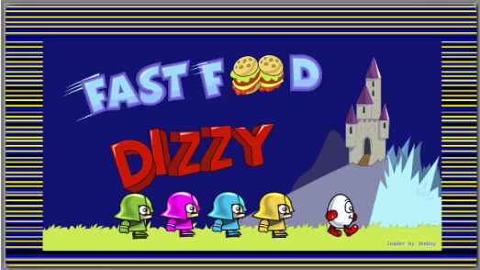
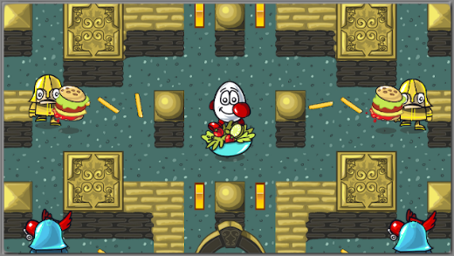
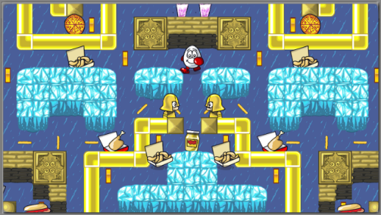

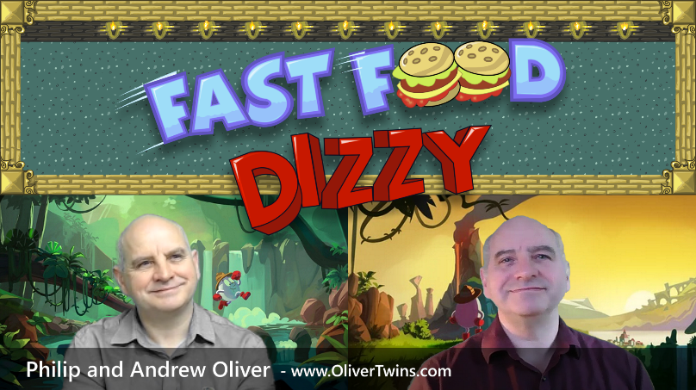
Fast Food Dizzy for FUZE on Nintendo Switch is a complete rewrite of an early ‘Best-Selling’ Dizzy title released in the eighties on the Sinclair ZX Spectrum, Amstrad CPC, Commodore 64, Amiga and Atari ST home computer systems.
See the game in action along with comments from The Oliver Twins here - Fast Food trailer
Find out more about the incredible
Oliver Twins at www.OliverTwins.com

FUZE⁴ Nintendo Switch is available now on the Nintendo eShop for just £12.99 / €14.99 / $19.99
For an overview of FUZE⁴ Nintendo Switch: https://www.fuze.co.uk/nintendo-switch
Visit https://fuzearena.com/ and join in with a community of enthusiastic coders eager to learn, share tips and give advice. FUZE Arena runs regular Game Jams and competitions. Create a masterpiece, submit it to the Showcase Gallery for others to play all over the world.
Dizzy was developed by The Oliver Twins and Codemasters. Fast Food Dizzy for FUZE, was created, and is distributed, with the kind permission of the copyright holders. DIZZY is a trademark of Codemasters.
Additional artwork is available here www.fuze.co.uk/press
For more information on FUZE please email contact@fuze.co.uk

