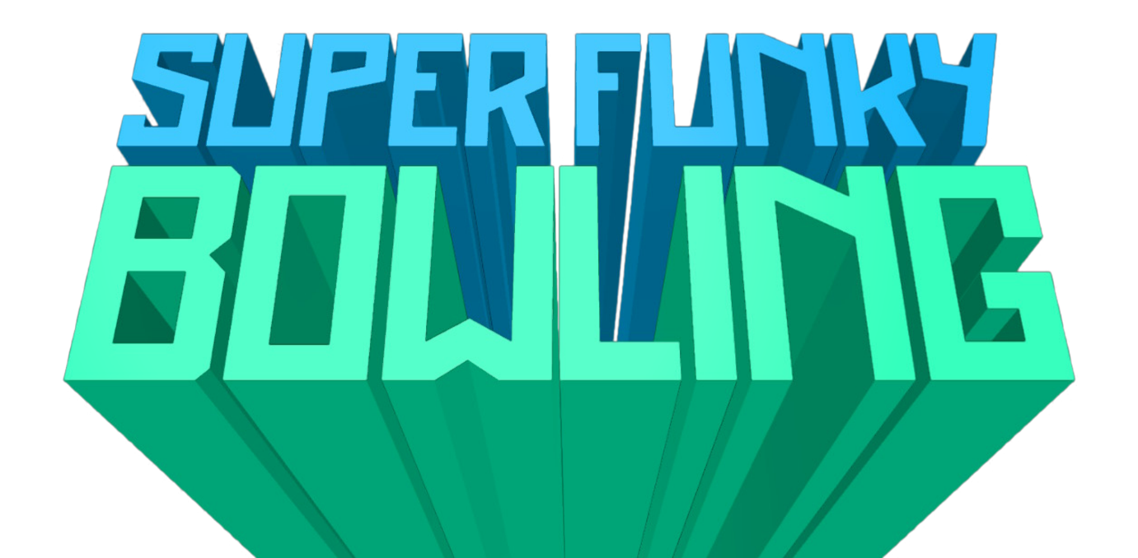

SUPER FUNKY BOWLING
Fast, Funky, Physics Fun!
Put your thumbs to the test in a journey through 64 awesome handcrafted levels. Max out your skills and improve your times to be the very best!
September 27th - If you love action-based puzzle games, this could be right up your alley! Enjoy the thrill of fast-paced, skill-intensive physics action in a wonderfully nostalgic title created by indie developer, Nathaniel Strub (aka. Scrubz)!
SUPER FUNKY BOWLING
SUPER FUN – Lose yourself in immediately accessible, intuitive gameplay!
SUPER FUNKY – Awesome original music compositions and sound effects!
SUPER CHALLENGING – Master advanced movement techniques in order to beat the clock!
SUPER SECRETS – Unlock hidden levels, player features and secret times by completing more and more difficult challenges!
SUPER SPEEDRUN – Take on the speedrun challenge and put your skills to the ultimate test!

Super Funky Bowling is available exclusively on the Nintendo eShop from October 14th 2022 for only 2.99 ($£€)
Made with FUZE⁴ Nintendo Switch
Super Funky Bowling was developed using FUZE⁴ Nintendo Switch, and is the premier release under the ‘Made with FUZE’ initiative – a new, super accessible route to getting your games published on the Nintendo eShop and earning you money!
About Scrubz
Nathaniel is 20 years old, based Texas and studies computer science and games development.
“I was surprised how quickly I was able to pick up and learn FUZE. Within a few days I had learned the basics and started working on my first game, Super Funky Bowling. Creating the game was definitely a challenge, but it was an enjoyable learning experience. FUZE had plenty of tutorials to help me out, tons of assets, and a welcoming community, all of which made it a great platform to develop my game.” – Nathaniel Strub (AKA Scrubz)

About FUZE
FUZE Technologies Ltd, Oxfordshire, England has a core focus on making learning to code as easy, accessible and enjoyable as possible. As well as local Coding & Gaming activities, FUZE provides award winning, curriculum-mapped, computing workshops to schools and STE(A)M events country-wide.
FUZE developed FUZE⁴ Nintendo Switch, an application designed to bring accessible coding, and even games publishing, to the world’s best-selling games platform and will soon announce versions for additional platforms.
Supporting its activities, FUZE offers freely downloadable teaching content, a vast number of YouTube coding tutorials and operates the FUZE Arena, a community driven platform for coding advice, creative inspiration, and events such as Game Jams and competitions.

To find out more about FUZE Technologies Ltd:
fuze.co.uk
For FUZE Arena, YouTube, Twitter & TikTok
fuzearena.com / @fuzearena
General & Education enquires: contact@fuze.co.uk
Press:
molly@fuze.co.uk
Press packs: fuze.co.uk/press.html

